HAPPY HOLIDAYS & HAPPY NEW YEAR 2024!



My mother always said, “Susanne, you make a production out of everything.”

And so Carter Productions was born.

3031 North 75th Street Milwaukee, WI 53212 414-788-2216

[carterproductions@sbcglobal.net](mailto:carterproductions@sbcglobal.net) [www.carterproductions.com](http://www.carterproductions.com)

BELOW IS THE SCREEN SHOT of our ZOOM RECORDED DANCE from THE FREE ZOOM PARKINSON’S DANCE CLASS. Go to our web page and see the dance. Maybe you will consider a donation to keep this service free to those with Parkinson’s.

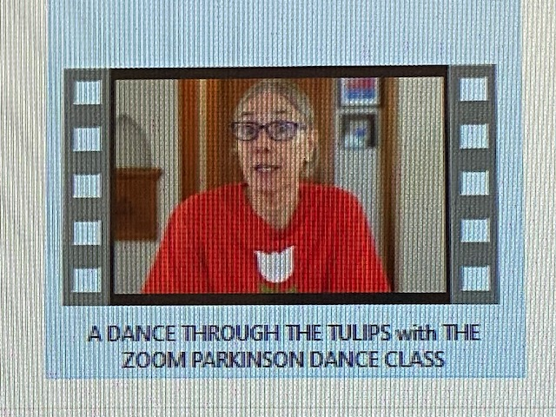

ANOTHER SUCCESSFUL YEAR FOR CARTER PRODUCTIONS.

SWEATnDANCE, YOGA MIX are LIVE & on ZOOM. I presented in two PARKINSON SYMPOSIUMS with Froedtert & the Medical Hospital & the Wisconsin Parkinson Association.

PAUL’S MUSIC continues to grow in his practice and accompaniment to Carter Productions classes. Paul is also busy with grandchildren and spending a lot of time with his Mom.

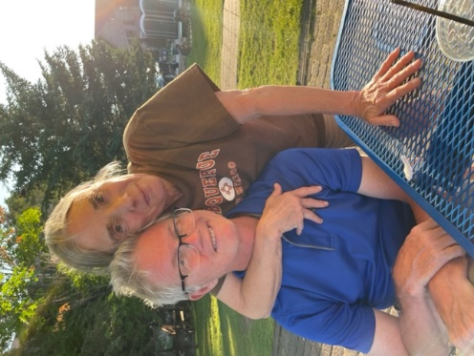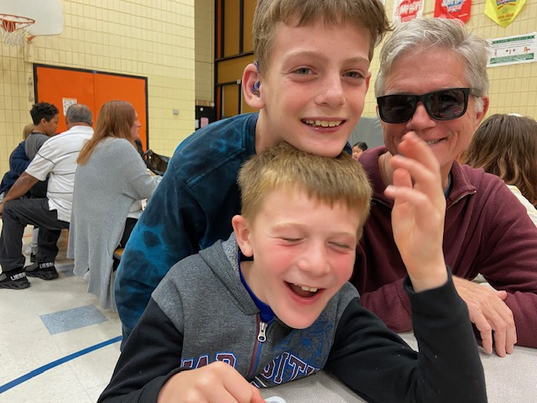

BATHROOM RENO AND WE ARE GOING SOLAR.

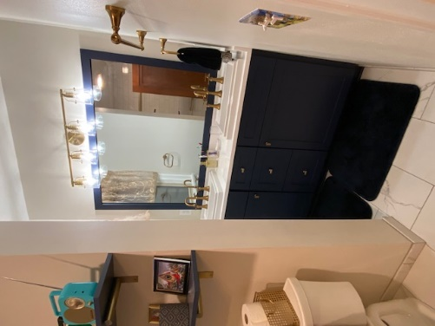 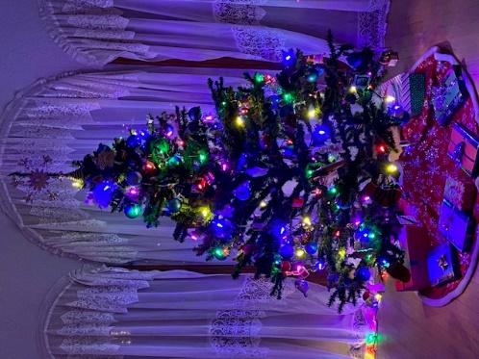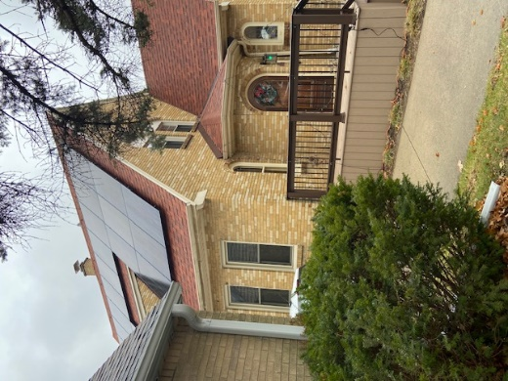

SALMON FISHING on Lake Michigan with a visit by Uncle Rich, a fisherman par excellent. We enjoyed this catch in Sturtevant with family and a special surprise visit from Aunt Cheryl.

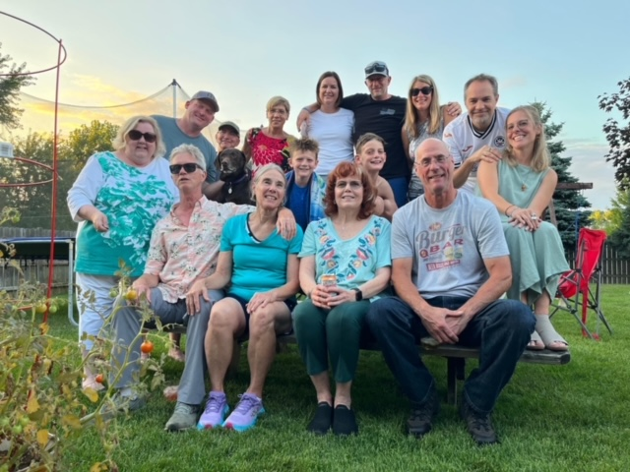

LOVE to THE MEADS, MOTTS, CARTERS, MUCHAS, GABRIELS, MIELCAREKS, SCHUELKE’S, cousins, friends, neighbors, FAITHFUL STUDENTS, doctors, dentists, thankful to Medicare, Physical Therapy, Strength Training, Yoga and Meditation.

LOVE TO ALL.

LIGHT TO ALL.

PEACE TO ALL.

NAMASTE.